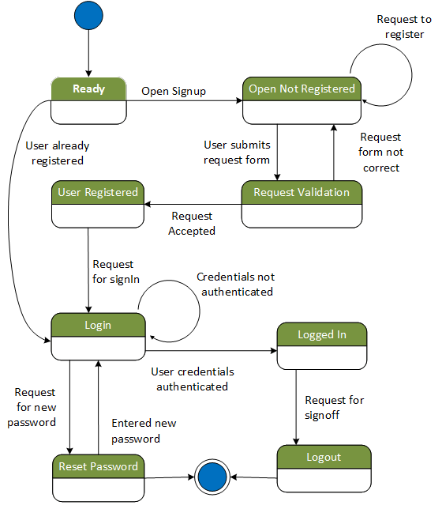

Fig: State machine Diagram for class “User”

Description:

This State machine diagram illustrates the state transition for class “User”. Initial state ‘Ready’ represents the system ready to accept either user login or new registration request. If user is not requested and upon registration request, system state changed to ‘Open not registered state” where user can raise request by filling user registration form. State won’t change until user fills in the correct form and submits the form. Upon user request to submit the form, system will change state to “request validation” state, where system verifies and validates the form for correctness and completeness. System accepts the registration request as “User registered” form. User can only Login into the system when system would be “Login” state and upon credential authentication, system could to “Logged in” state and would be ready to use. There is another state to reset the password and after user signoff the system state change to logout and won’t allow user to access the system.